DROP TABLE Member_Information CASCADE CONSTRAINTS;

DROP TABLE Project_Information CASCADE CONSTRAINTS;

DROP TABLE Product_Information CASCADE CONSTRAINTS;

DROP TABLE Payment_Information CASCADE CONSTRAINTS;

CREATE TABLE Project_Information (Project_id number primary key, Project_Type varchar2(20), Location varchar2(20));

CREATE TABLE Member_Information (Member_id number, First_name varchar2(20), Last_Name varchar2(20), Member_Type varchar2(20), Depertment varchar2(20), Email varchar2(20), Phone_Number number, Project_id number, primary key(Member_id), foreign key(Project_id) references Project_Information(Project_id));

CREATE TABLE Product_Information (Product_id number, Product_Name varchar2(20), Growing_Cost number, Selling_Price number, Project_id number, primary key(Product_id), foreign key(Project_id) references Project_Information(Project_id));

CREATE TABLE Payment_Information(Order_id number, Order_Amount number, Order_Date date, Product_id number, Project_id number, primary key(Order_id), foreign key(Product_id) references Product_Information(Product_id), foreign key (Project_id) references Project_Information(Project_id));

INSERT INTO Project_Information VALUES (01,'Herbs Garden','C Block Balcony');

INSERT INTO Project_Information VALUES (02,'Strawberry Garden','D Block Balcony');

INSERT INTO Project_Information VALUES (03,'Vertical Launge','Cafeteria');

INSERT INTO Project_Information VALUES (04,'Flower Garden','KICT Premises');

INSERT INTO Project_Information VALUES (05,'Green House','E Block Balcony');

INSERT INTO Project_Information VALUES (06,'Vegetable Garden','KICT Rooftop');

INSERT INTO Project_Information VALUES (07,'Edible Greenwall','General Office');

INSERT INTO Project_Information VALUES (08,'Container Garden','B Block 2ndFloor');

INSERT INTO Project_Information VALUES (09,'Strawberry Garden','Near Bus Stop');

INSERT INTO Member_Information VALUES (100,'Potol','Tula','Student','BIT','pt@live.iium.edu.my', 0938273, 06);

INSERT INTO Member_Information VALUES (101,'Hitasha','Khan','Student','BIT','hk@live.iium.edu.my', 0936573, 05);

INSERT INTO Member_Information VALUES (102,'Roddur','Roy','Staff','Academic','rr@live.iium.edu.my', 1136573, 01);

INSERT INTO Member_Information VALUES (103,'Kacchi','Miah','Staff','Finance','km@live.iium.edu.my', 1139993, 02);

INSERT INTO Member_Information VALUES (104,'Halar','Hala','Student','BCS','hh@live.iium.edu.my', 1137793, 05);

INSERT INTO Member_Information VALUES (105,'Dhur','Beta','Staff','Transportation','db@live.iium.edu.my', 1130093, 07);

INSERT INTO Member_Information VALUES (106,'Thaba','Dimu','Student','BCS','td@live.iium.edu.my', 0130093, 06);

INSERT INTO Member_Information VALUES (107,'Vavago','Vava','Student','BIT','vv@live.iium.edu.my', 0130223, 01);

INSERT INTO Member_Information VALUES (108,'Nube','Pillar','Student','BCS','np@live.iium.edu.my', 0136623, 02);

INSERT INTO Member_Information VALUES (109,'Mir','Jafor','Staff','Finance','mj@live.iium.edu.my', 0130023, 03);

INSERT INTO Member_Information VALUES (110,'Bodmaish','Pola','Staff','Student Affair','bp@live.iium.edu.my', 6930023, 04);

INSERT INTO Member_Information VALUES (111,'Dolund','Modi','Student','BCS','dm@live.iium.edu.my', 6930993, 08);

INSERT INTO Member_Information VALUES (112,'Melania','Gandhi','Student','BIT','mg@live.iium.edu.my', 6931193, 03);

INSERT INTO Member_Information VALUES (113,'Akash','Patal','Student','BCS','ap@live.iium.edu.my', 6931003, 02);

INSERT INTO Member_Information VALUES (114,'Jibon','Moron','Staff','Academic','jm@live.iium.edu.my', 0031003, 06);

INSERT INTO Member_Information VALUES (115,'Nibba','Nibbi','Staff','Academic','nn@live.iium.edu.my', 0022003, 05);

INSERT INTO Member_Information VALUES (116,'Juan','Bura','Student','BIT','jb@live.iium.edu.my', 8822003, 04);

INSERT INTO Member_Information VALUES (117,'Agun','Fagun','Student','BIT','af@live.iium.edu.my', 8865003, 04);

INSERT INTO Member_Information VALUES (118,'Pothvrosto','Alom','Student','BCS','pa@live.iium.edu.my', 8865223, 06);

INSERT INTO Member_Information VALUES (119,'Hotasha','Natasha','Student','BCS','hn@live.iium.edu.my', 8865200, 06);

INSERT INTO Member_Information VALUES (120,'Jama','Jamai','Student','BCS','jj@live.iium.edu.my', 8865110, 07);

INSERT INTO Member_Information VALUES (121,'Dhisum','Dhisumai','Staff','General Office','dd@live.iium.edu.my', 8665110, 09);

INSERT INTO Member_Information VALUES (122,'Mogoj','Mostisko','Staff','General Office','mm@live.iium.edu.my', 8661210, 01);

INSERT INTO Member_Information VALUES (123,'India','Varoot','Student','BCS','iv@live.iium.edu.my', 8661270, 08);

INSERT INTO Member_Information VALUES (124,'Mokles','Sokles','Student','BCS','ms@live.iium.edu.my', 8832003, 09);

INSERT INTO Member_Information VALUES (125,'Unnoyoner','Juyar','Student','BIT','uj@live.iium.edu.my', 8811003, 04);

INSERT INTO Member_Information VALUES (126,'Disitaal','Besamal','Student','BIT','dbe@live.iium.edu.my', 8822003, 08);

INSERT INTO Member_Information VALUES (127,'Sentii','Khan','Student','BCS','sk@live.iium.edu.my', 8821103, 03);

INSERT INTO Member_Information VALUES (128,'Mela','Hoise','Staff','Finance','mh@live.iium.edu.my', 6021103, 02);

INSERT INTO Member_Information VALUES (129,'Eibar','Biday','Student','BCS','eb@live.iium.edu.my', 6044103, 01);

INSERT INTO Member_Information VALUES (130,'Tada','Baibye','Student','BIT','tb@live.iium.edu.my', 6014103, 09);

INSERT INTO Product_Information VALUES (500,'Tulip',100,170,04);

INSERT INTO Product_Information VALUES (501,'Strawberry',300,500,09);

INSERT INTO Product_Information VALUES (502,'PeaceLily',120,180,04);

INSERT INTO Product_Information VALUES (503,'Spider Plant',200,320,03);

INSERT INTO Product_Information VALUES (504,'Broccoli',150,190,06);

INSERT INTO Product_Information VALUES (505,'Tomato',130,180,06);

INSERT INTO Product_Information VALUES (506,'Pepper',150,210,06);

INSERT INTO Product_Information VALUES (507,'African Violet',230,400,03);

INSERT INTO Product_Information VALUES (508,'Baby Tear',250,500,03);

INSERT INTO Product_Information VALUES (509,'Lipstick Plant',270,500,03);

INSERT INTO Product_Information VALUES (510,'Ginseng',80,170,05);

INSERT INTO Product_Information VALUES (511,'Mashrooms',100,190,05);

INSERT INTO Product_Information VALUES (512,'Lettuce',90,120,05);

INSERT INTO Product_Information VALUES (513,'Basil',130,200,01);

INSERT INTO Product_Information VALUES (514,'Lemon Balm',70,130,01);

INSERT INTO Product_Information VALUES (515,'Chives',80,130,01);

INSERT INTO Product_Information VALUES (516,'Orchids',400,900,08);

INSERT INTO Product_Information VALUES (517,'Mandevillas',200,350,08);

INSERT INTO Product_Information VALUES (518,'Christmas cactus',100,210,04);

INSERT INTO Product_Information VALUES (519,'Pineberry',300,550,02);

INSERT INTO Product_Information VALUES (520,'Strasberry',270,530,02);

INSERT INTO Payment_Information VALUES (1000,500,to_date('30-JUN-2020'),501,09);

INSERT INTO Payment_Information VALUES (1001,180,to_date('21-JAN-2020'),505,06);

INSERT INTO Payment_Information VALUES (1002,500,to_date('22-FEB-2020'),508,03);

INSERT INTO Payment_Information VALUES (1003,170,to_date('01-SEP-2020'),510,05);

INSERT INTO Payment_Information VALUES (1004,400,to_date('11-AUG-2020'),513,01);

INSERT INTO Payment_Information VALUES (1005,900,to_date('23-JUL-2020'),516,08);

INSERT INTO Payment_Information VALUES (1006,530,to_date('29-MAR-2020'),520,02);

INSERT INTO Payment_Information VALUES (1007,550,to_date('29-MAR-2020'),519,02);

INSERT INTO Payment_Information VALUES (1008,260,to_date('12-APR-2020'),515,01);

INSERT INTO Payment_Information VALUES (1009,190,to_date('22-OCT-2020'),504,06);

INSERT INTO Payment_Information VALUES (1010,170,to_date('27-DEC-2020'),500,04);

INSERT INTO Payment_Information VALUES (1011,360,to_date('02-NOV-2020'),502,04);

INSERT INTO Payment_Information VALUES (1012,630,to_date('22-MAY-2020'),506,06);

INSERT INTO Payment_Information VALUES (1013,320,to_date('10-JUN-2020'),503,03);

INSERT INTO Payment_Information VALUES (1014,400,to_date('19-JUL-2020'),507,03);

INSERT INTO Payment_Information VALUES (1015,190,to_date('19-JUL-2020'),511,05);

INSERT INTO Payment_Information VALUES (1016,240,to_date('13-MAY-2020'),512,05);

INSERT INTO Payment_Information VALUES (1017,130,to_date('18-AUG-2020'),514,01);

INSERT INTO Payment_Information VALUES (1018,350,to_date('05-OCT-2020'),517,08);

INSERT INTO Payment_Information VALUES (1019,500,to_date('25-DEC-2020'),501,09);

INSERT INTO Payment_Information VALUES (1020,210,to_date('29-DEC-2020'),506,06);

**Queries**

**Select statement:**

Member information table-

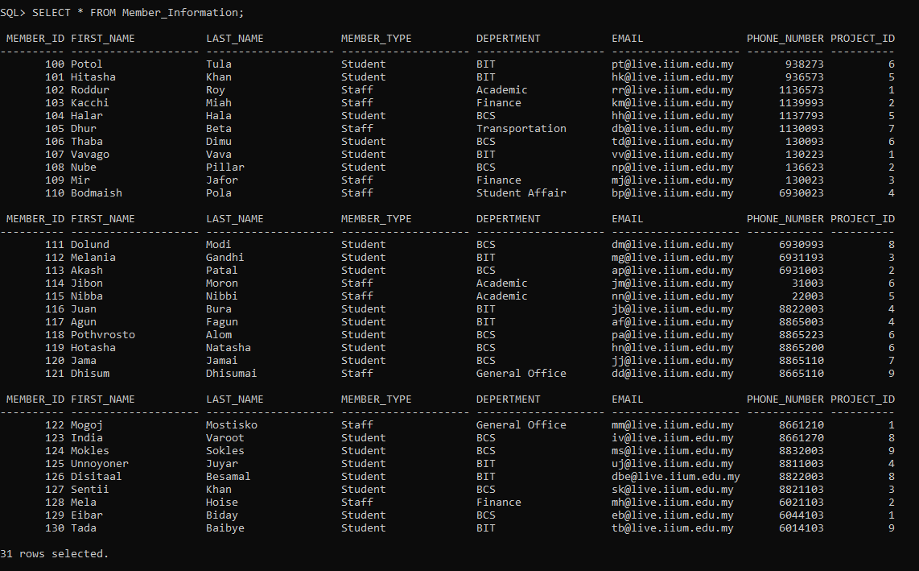

Project information table –

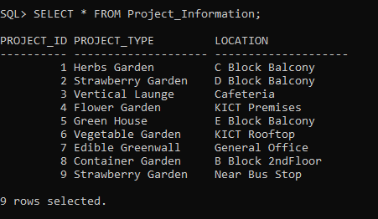

Product information table –

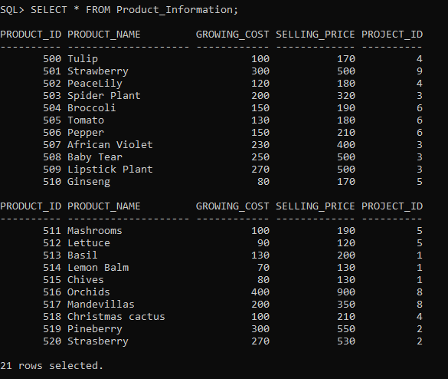

Payment information table –

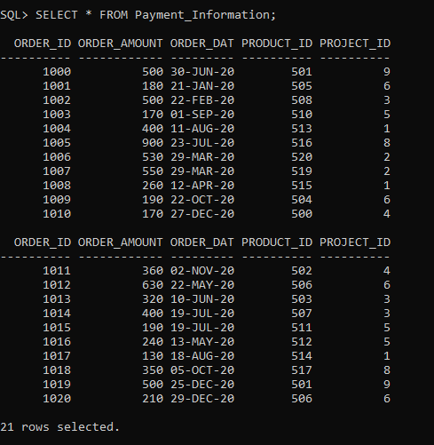

SELECT CONCAT(First_Name,Last_Name)AS “Full_Name”,Member_Type,Email,Phone_Number FROM Member_Information where Depertment = ‘Student Affair’;



**Update:**

UPDATE Member_Information SET Last_name = ‘Dhulai’ Where Member_id = 112;

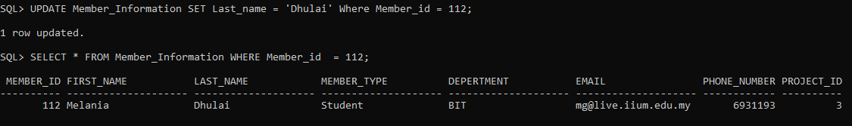

**Delete:**

DELETE FROM Member_Information WHERE First_Name =’Melania’;



**Insert:**

INSERT INTO Member_Information VALUES (112,’Melania’,’Trump’,’Student’,’BIT’,’mg@live.iium.edu.my’, 6931193, 03);



Calculating no of staff in the project -

SELECT Count(Member_Type) AS "Number of Staff" from Member_Information where Member_Type = 'Staff';

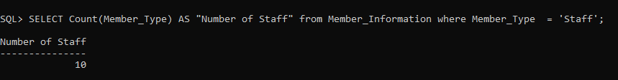

Higher profitable products in descending order –

SELECT Product_name,Selling_Price-Growing_Cost AS "Profit" From Product_Information ORDER BY Selling_price-Growing_cost DESC;

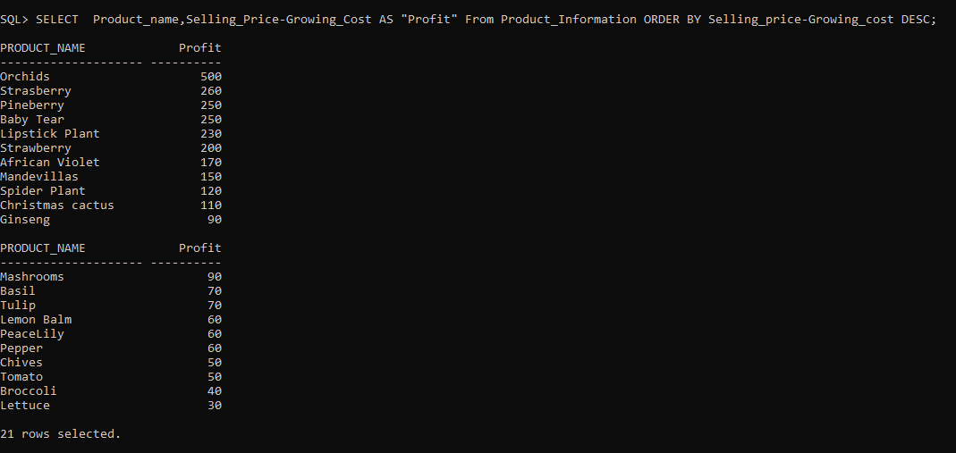

To see how many members in staff and student:

SELECT Member_Type,COUNT(member_id) AS "Number of Members" FROM Member_Information GROUP BY member_type ;

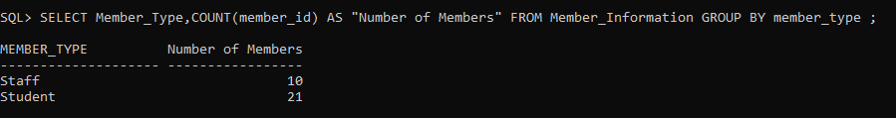

**Join –**

SELECT First_Name,Last_Name,Member_Type,Depertment FROM Project_Information, Member_Information WHERE Project_Information.Project_id = Member_Information.Project_id and Project_Type = 'Flower Garden';

SELECT Product_Name,Project_Type,Growing_Cost,Order_Amount FROM Project_Information,Product_Information,Payment_Information WHERE Project_Information.project_id = Product_information.Project_id and Product_Information.Product_id = Payment_Information.Product_id;

SELECT Product_Name FROM Product_Information WHERE Product_id = any(SELECT product_id FROM Payment_Information WHERE Order_Amount>300);

SELECT Project_Type AS "Top Products of MCO" FROM Project_Information WHERE Project_id = any(SELECT Project_id FROM Payment_information WHERE Order_Date Between '01-JUN-2020' AND '30-SEP-2020' AND Order_Amount>400);

View –

DROP VIEW Complex;

CREATE VIEW Complex AS SELECT Product_Name,Project_Type,Growing_Cost,Order_Date,Order_Amount FROM Project_Information,Product_Information,Payment_Information WHERE Project_Information.project_id = Product_information.Project_id and Product_Information.Product_id = Payment_Information.Product_id;

SELECT Product_Name, Project_Type, Order_Date,Order_Amount-Growing_Cost AS "Profit" FROM Complex Where Order_Date BETWEEN '01-OCT-2020' AND '31-DEC-2020' ORDER BY Order_Amount-Growing_Cost DESC;

**Extra queries –**

SELECT COUNT(Project_id) from Payment_Information Group By Project_id Having Count(Project_id)>2;